Handout 6.4: Neighborhood Map and Price Comparison
Name: ____________________________________ Date: ______________ Period: ______
Everything in this handout is made up for class. The neighborhood is not a real place. The prices are written to look like a real Long Island supermarket and a real corner store. This handout is not about anybody’s real home.

Part 1. The two words
Food insecurity means _____________________________________________________
Line 2: _____________________________________________________________________________
Food desert means ________________________________________________________
Line 4: _____________________________________________________________________________

The four things that create a food desert
Cause | One example
Distance
Transportation
Price
Selection (what the store actually stocks)

Part 2. The neighborhood
Maple Park. About 4,000 people live in the twelve blocks below. There is one full supermarket, three convenience stores, one bus line, and no sidewalk on Route 9 between Elm and the supermarket.
Scale: 1 inch on this map = 0.4 miles. One block = about 0.1 miles.
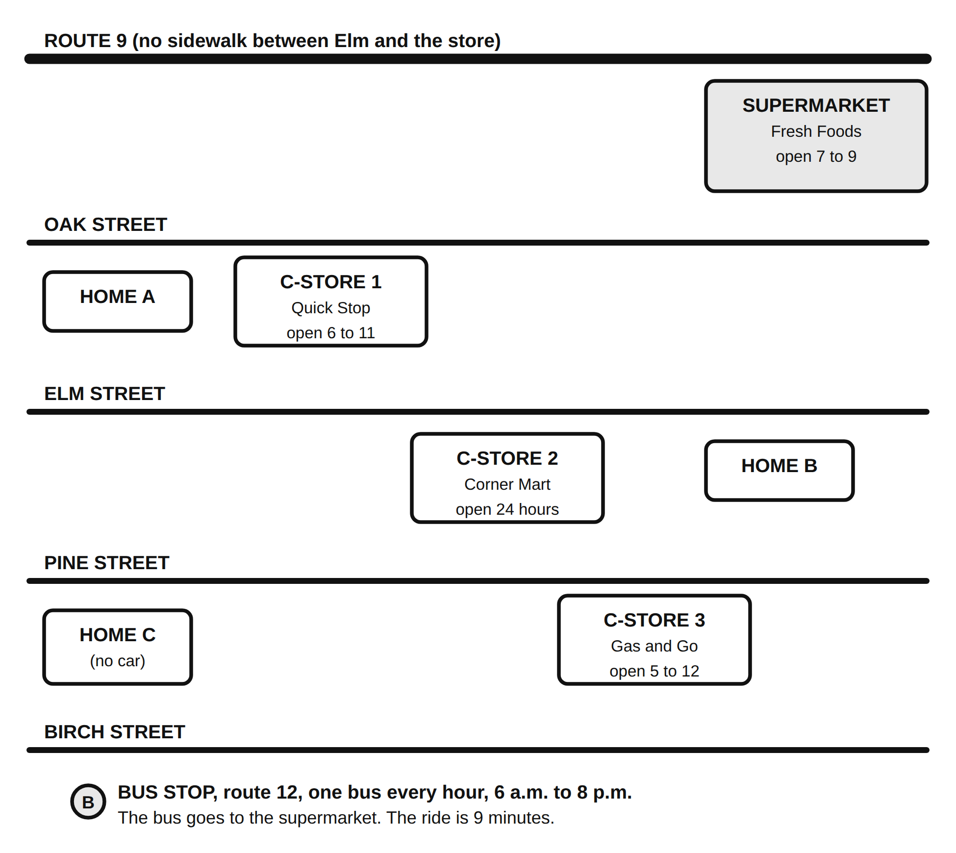
The neighborhood map: Route 9, four streets, three homes, three convenience stores, the supermarket and the bus stop

Measure it
Use a ruler and the scale. Measure the straight-line distance. Then add 20 percent for turns.
From | To the supermarket | To the nearest convenience store
Home A | ______ miles | ______ miles, which one: __________
Home B | ______ miles | ______ miles, which one: __________
Home C | ______ miles | ______ miles, which one: __________
Highlight the walking route from Home C to the supermarket. How many blocks is it? ______
Which home has the hardest trip to the supermarket? ______
Give two reasons: ___________________________________________________________
Line 4: _____________________________________________________________________________
What would make it easier? Name one change to the neighborhood, not to the family.
Answer: _____________________________________________________________________________

Part 3. Twenty dollars, two stores
You are shopping for one dinner for a family of four. You have $20. Build a cart at each store. Check the items you buy and add up the cost.

Fresh Foods Supermarket (1.4 miles from Home C)
Item | Size | Price | Check if you buy it | Cost
Chicken thighs | 2 lb pack | $4.98
Ground turkey | 1 lb | $4.49
Dry black beans | 1 lb bag | $1.49
Canned black beans | 15 oz | $0.99
Rice | 2 lb bag | $2.29
Pasta | 1 lb box | $1.29
Pasta sauce | 24 oz jar | $2.49
Potatoes | 5 lb bag | $3.99
Onions | 3 lb bag | $2.99
Carrots | 2 lb bag | $1.99
Broccoli | 1 head | $1.99
Frozen mixed vegetables | 12 oz | $1.29
Bananas | 1 lb (about 3) | $0.69
Apples | 3 lb bag | $3.99
Milk | 1 gallon | $3.99
Eggs | 1 dozen | $3.49
Shredded cheese | 8 oz | $2.99
Bread | 1 loaf | $2.49
Tortillas | 10 count | $2.49
Supermarket cart total: $__________
What is the dinner? _________________________________________________________
Does it feed four? yes / no

Corner Mart (0.2 miles from Home C, open 24 hours)
Item | Size | Price | Check if you buy it | Cost
Canned black beans | 15 oz | $1.89
Rice | 14 oz box | $2.79
Pasta | 1 lb box | $2.49
Pasta sauce | 16 oz jar | $3.49
Frozen pizza | 1 | $6.99
Canned soup | 10.5 oz | $2.29
Canned corn | 15 oz | $1.79
White bread | 1 loaf | $3.49
Milk | 1 quart | $2.79
Eggs | 6 count | $3.29
Sliced cheese | 6 slices | $2.99
Hot dogs | 8 count | $4.49
Ramen noodle packs | 3 packs | $1.50
Chips | 1 large bag | $4.29
Soda | 2 liter | $3.19
Candy bar | 1 | $2.29
Fresh vegetables |  | not sold here
Fresh fruit |  | 1 banana, $0.99
Fresh meat |  | not sold here
Corner Mart cart total: $__________
What is the dinner? _________________________________________________________
Does it feed four? yes / no

The comparison
The difference in how much food: the supermarket cart bought about ____________ pounds of food for $20. The Corner Mart cart bought about ____________ pounds for $20.
The difference in food: in one sentence, what does the supermarket family eat that the Corner Mart family does not?
Answer: _____________________________________________________________________________
The item that was not available at all at Corner Mart: ____________________

Part 4. Five responses. Rank them, then pick two.
Response | What it is | Rank 1 to 5 (1 = helps Maple Park most)
Food pantry | A place, often run by a church, a school, or a nonprofit, that gives out groceries for free. Some are open one day a week
SNAP and WIC | Government programs. SNAP puts money on a card that can be used for groceries at approved stores. WIC gives certain foods to pregnant women, new mothers, babies, and young children. Both are run through the state
Community garden | A shared plot where neighbors grow food. Some are run by a town, some by a school, some by a neighborhood group
Mobile market | A truck or van that parks in a neighborhood on a schedule and sells fresh produce at low prices
School meals | Breakfast and lunch served at school. In many New York schools every student eats at no charge
My top two, with evidence from the map or the price lists:
Choice 1: ______________________ Evidence: ____________________________________
Choice 2: ______________________ Evidence: ____________________________________

Exit card
A food desert is ______________________________________________________, and the thing that would help the most is ______________________ because ___________________________________________________________________________.

